Phase 1: Deliverable 1 - Team Charter & Company Proposal
​I. Team Charter
1. Team Identification
• ​Team Name: Group 8
• ​Primary Point of Contact:
Name : Tsgabu Measho
Email : tgbal355@gmail.com
• ​Project Deadline: December 7, 2025

- Team Member and Roles
Team Members | Roles
Faniel Negasi | Interviewer & Documentation Lead
Julas Mohammednur | Interviewer & note taker
Netsanet Haile | Website Assessor & CMMI Process Analysis
Tsgabu Measho | PM & Prepare Questions for Interviewer
Mekbb Luel | Website Assessor & CMMI Process Analysis

3. Communication Plan and Schedule
• ​Communication Method: In-person meetings and digital check-ins.
Primary Communication Method: Telegram Group.
Secondary Communication Method (URGENT MATTERS): Direct Phone Call/SMS
Document Sharing: Google Drive via Telegram Group.

​Meeting Schedule:
Day | Time
Wednesday | at 1:30 PM LT (In-person)
Friday | at 3:30 AM LT (In-person)
Saturday | at 1:30 PM LT (Telegram Check-in)

​4. Team Affirmation Statement
- ​"We, the members of the team, affirm that we have read and fully understand the project instructions, scope, requirements, and the final deadline of December 7, 2025. We commit to completing all deliverables according to these specifications."
​(Affirmed by all members)

​II. Company Proposal
​1. Chosen Company
- ​Company Name: AllenaTech Electronic Technologies S.C.
​2. Justification for Suitability
- ​After brainstorming and evaluating alternatives like Wan’a Technologies and Luna tech PLC, Allenatech was selected because it best meets the criteria for a CMMI study candidate. Allenatech is a complex public share company that develops and maintains integrated, large-scale enterprise solutions (including the Menzo Core Banking System, Fetlee SCM System, and RUFTA Electronic Medical Record). The scope of these products and the nature of their major clients (such as the Government of Tigray and Wegagen Bank) confirm that the company operates with complex and established organizational processes, providing richer material for CMMI analysis compared to the other options.
​3. Verifiable Source of Information
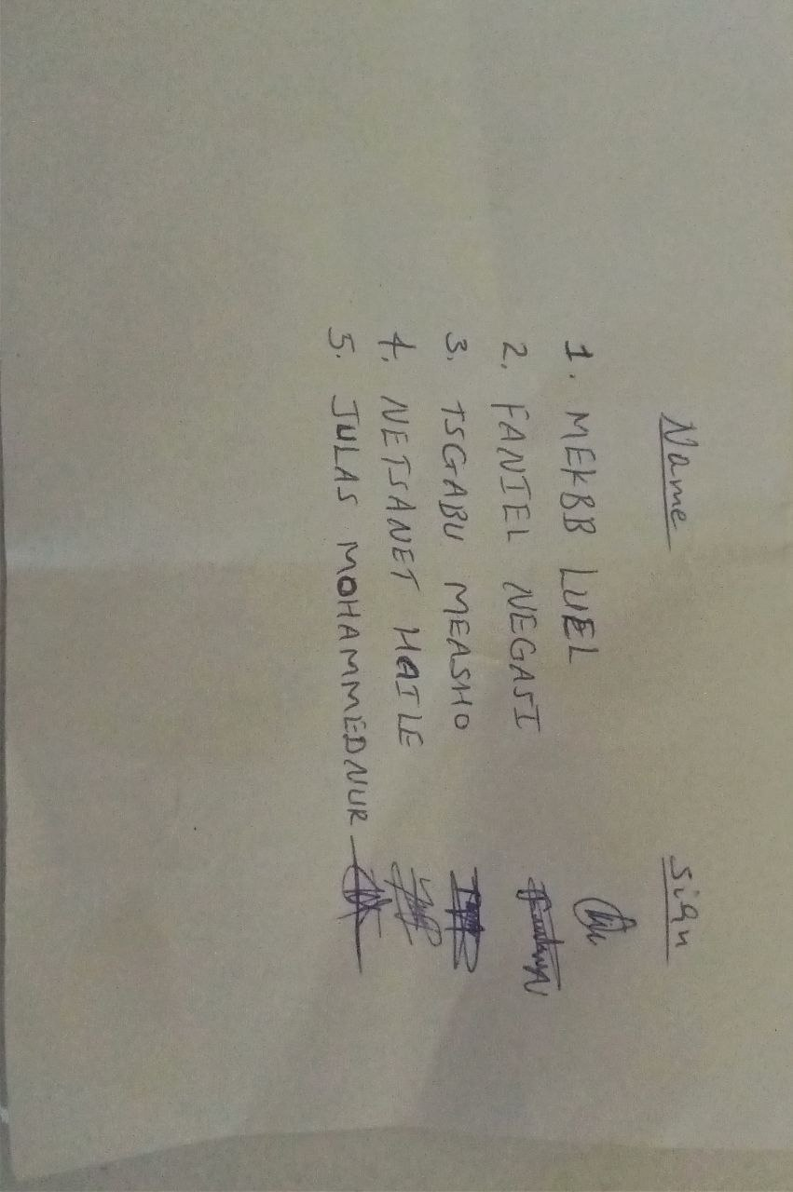
- The suitability assessment is based on the company's official website, specifically the "Products" and "Customers" sections detailing their integrated system offerings. (Source URL: https://www.allenatech.net)
Signatures

